# Art and power:

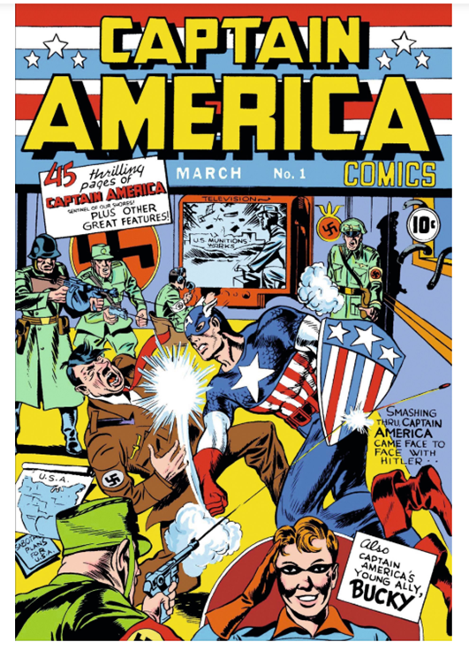

<https://englishforlearning.home.blog/axe-3-art-and-power/>

Propaganda through art

# Diversity and inclusion:

<https://www.predictiveindex.com/blog/5-diversity-and-inclusion-quotes-for-the-workplace/#:~:text=Here%20are%20five%20diversity%20and%20inclusion%20quotes%20to,wiser%2C%20more%20inclusive%2C%20and%20better%20as%20an%20organization.%E2%80%9D>

## “Inclusion is not a matter of political correctness. It is the key to growth.”

Jesse Jackson

# Territory and memory:

## “Absence makes the heart grow fonder”

Unknown

## “We leave something of ourselves behind when we leave a place, we stay there, even though we go away. And there are things in us that we can find again only by going back there”.

Pascal Mercier, Night Train to Lisbon

memory

## “The father backward you can look, the further forward you are likely to see”

Winston Churchill

## “Never in the field of human conflict was so much owed by so many to so few”

Winston Churchill

## “Success is not final; failure is not fatal: it is the courage to continue that counts.”

Winston Churchill

## “That’s one small step for man. One giant leap for humanity.”

Neil Armstrong

# Identities and exchanges:

## “Intelligence Is the ability to adapt to change”

Stephen Hawking

## “I am no bird; and no net ensnares me: I am a free human being with an independent role.”

Charlotte Brontë, Jane Eyre